ANDROID PROGRAMMING

PRACTICAL FILE


Objective of Practical 1:
Create “Hello World” application that will display “Hello World” in the middle of the screen in the emulator. Also display “Hello World” in the middle of the screen in the android phone.
Code:
activity_main.xml
<?xml version="1.0" encoding="utf-8"?>
<androidx.constraintlayout.widget.ConstraintLayout xmlns:android="http://schemas.android.com/apk/res/android"
xmlns:app="http://schemas.android.com/apk/res-auto"
xmlns:tools="http://schemas.android.com/tools"
android:layout_width="match_parent"
android:layout_height="match_parent"
tools:context=".MainActivity">
<TextView
android:layout_width="wrap_content"
android:layout_height="wrap_content"
android:rotationX="7"
android:text="Hello World!"
android:textColor="@color/teal_200"
android:textSize="50sp"
android:textStyle="bold|italic"
app:layout_constraintBottom_toBottomOf="parent"
app:layout_constraintEnd_toEndOf="parent"
app:layout_constraintLeft_toLeftOf="parent"
app:layout_constraintRight_toRightOf="parent"
app:layout_constraintStart_toStartOf="parent"
app:layout_constraintTop_toTopOf="parent"
app:layout_constraintVertical_bias="0.484" />
</androidx.constraintlayout.widget.ConstraintLayout>

MainActivity.java
package com.example.myapplication;
import androidx.appcompat.app.AppCompatActivity;
import android.os.Bundle;
public class MainActivity extends AppCompatActivity {
@Override
protected void onCreate(Bundle savedInstanceState) {
super.onCreate(savedInstanceState);
setContentView(R.layout.activity_main);
}
}

Output:
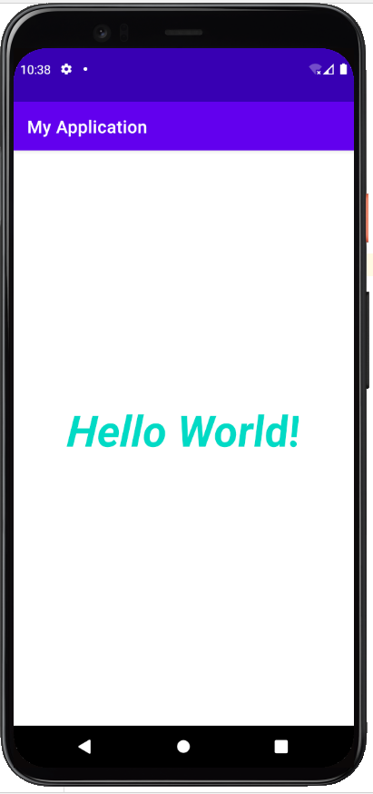

Objective of Practical 2:
Create an application to display various android activity lifecycle phases.
Code:
activity_main.xml
<?xml version="1.0" encoding="utf-8"?>
<androidx.constraintlayout.widget.ConstraintLayout xmlns:android="http://schemas.android.com/apk/res/android"
xmlns:app="http://schemas.android.com/apk/res-auto"
xmlns:tools="http://schemas.android.com/tools"
android:layout_width="wrap_content"
android:layout_height="wrap_content"
tools:context=".MainActivity">
<TextView
android:id="@+id/Display"
android:layout_width="0dp"
android:layout_height="wrap_content"
android:layout_marginLeft="100dp"
android:layout_marginBottom="250dp"
android:fontFamily="sans-serif-black"
android:text="@string/activity_life_cycle"
android:textAppearance="@style/TextAppearance.AppCompat.Large"
android:textColor="@color/purple_500"
android:textColorHighlight="@color/black"
android:textSize="50sp"
android:textStyle="bold|italic"
android:typeface="monospace"
app:layout_constraintBottom_toBottomOf="parent"
app:layout_constraintEnd_toEndOf="parent"
app:layout_constraintLeft_toLeftOf="parent"
app:layout_constraintRight_toRightOf="parent"
app:layout_constraintTop_toTopOf="parent"
app:layout_constraintVertical_bias="1.0" />
</androidx.constraintlayout.widget.ConstraintLayout>

MainActivity.java
package com.example.lifecycle;
import androidx.appcompat.app.AppCompatActivity;
import android.os.Bundle;
import android.widget.Toast;
public class MainActivity extends AppCompatActivity {
@Override
protected void onCreate(Bundle savedInstanceState) {
super.onCreate(savedInstanceState);
setContentView(R.layout.activity_main);
Toast t = Toast.makeText(getApplicationContext(), "Activity Created", Toast.LENGTH_SHORT);
t.show();
}
@Override
protected void onResume() {
super.onResume();
Toast t = Toast.makeText(getApplicationContext(), "Activity Resumed", Toast.LENGTH_SHORT);
t.show();
}
@Override
protected void onPause() {
super.onPause();
Toast t = Toast.makeText(getApplicationContext(), "Activity Paused", Toast.LENGTH_SHORT);
t.show();
}
@Override
protected void onStart() {
super.onStart();
Toast t = Toast.makeText(getApplicationContext(), "Activity Started", Toast.LENGTH_SHORT);
t.show();
}
@Override
protected void onStop() {
super.onStop();
Toast t = Toast.makeText(getApplicationContext(), "Activity Stopped", Toast.LENGTH_SHORT);
t.show();
}
@Override
protected void onDestroy() {
super.onDestroy();
Toast t = Toast.makeText(getApplicationContext(), "Activity Destroyed", Toast.LENGTH_SHORT);
t.show();
}
}

Output:
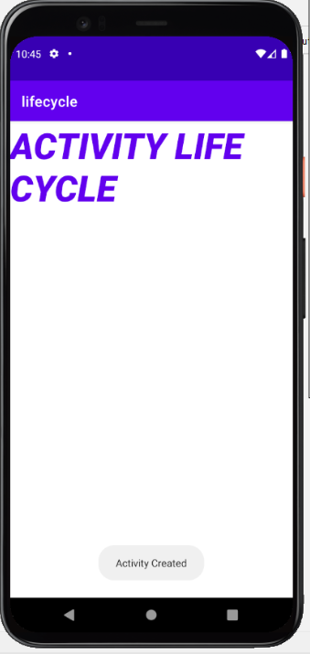
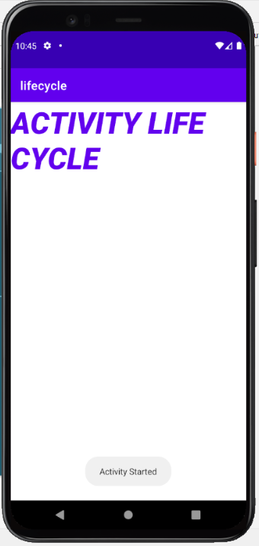
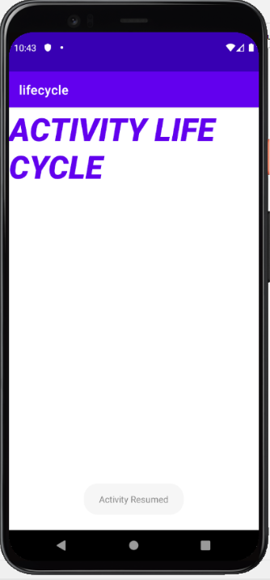
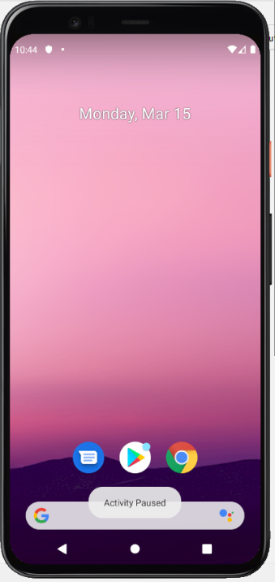
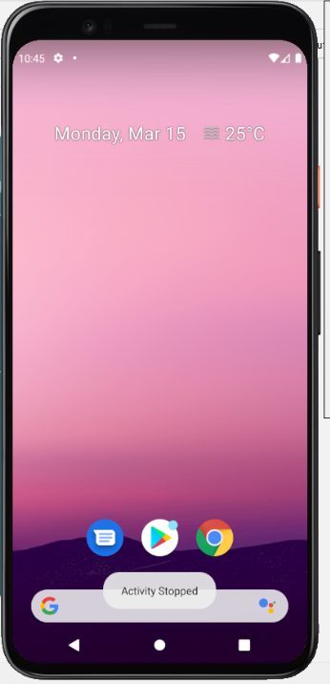
Objective of Practical 3:
Create an application with first activity with an editText and send button. On click of send button, make use of explicit intent to send text to second activity and display there in text view.
Code:
activity_main.xml
<?xml version="1.0" encoding="utf-8"?>
<RelativeLayout xmlns:android="http://schemas.android.com/apk/res/android"
xmlns:app="http://schemas.android.com/apk/res-auto"
xmlns:tools="http://schemas.android.com/tools"
android:layout_width="match_parent"
android:layout_height="match_parent"
tools:context=".MainActivity"
android:padding="20sp">
<EditText
android:layout_width="match_parent"
android:layout_height="wrap_content"
android:hint="Type Something"
android:id="@+id/edittext"
/>
<Button
android:layout_width="match_parent"
android:layout_height="wrap_content"
android:text="Submit"
android:textSize="20sp"
android:layout_below="@+id/edittext"
android:id="@+id/button"/>
</RelativeLayout>

MainActivity.java
package com.example.twoactivity;
import androidx.appcompat.app.AppCompatActivity;
import android.content.Intent;
import android.os.Bundle;
import android.view.View;
import android.widget.Button;
import android.widget.EditText;
public class MainActivity extends AppCompatActivity {
Button btn;
EditText et;
String st;
@Override
protected void onCreate(Bundle savedInstanceState) {
super.onCreate(savedInstanceState);
setContentView(R.layout.activity_main);
btn=findViewById(R.id.button);
et=findViewById(R.id.edittext);
btn.setOnClickListener(new View.OnClickListener(){
@Override
public void onClick(View v){
Intent i=new Intent(MainActivity.this,SecondActivity.class);
st=et.getText().toString();
i.putExtra("Value",st);
startActivity(i);
finish();
}
});
}
}

activity_second.xml
<?xml version="1.0" encoding="utf-8"?>
<RelativeLayout xmlns:android="http://schemas.android.com/apk/res/android"
xmlns:app="http://schemas.android.com/apk/res-auto"
xmlns:tools="http://schemas.android.com/tools"
android:layout_width="match_parent"
android:layout_height="match_parent"
tools:context=".SecondActivity">
<TextView
android:id="@+id/textView"
android:layout_width="match_parent"
android:layout_height="match_parent"
android:gravity="center"
android:text="Value"
android:textColor="@color/purple_200"
android:textSize="50sp"
android:textStyle="bold" />
</RelativeLayout>

SecondActivity.java
package com.example.twoactivity;
import androidx.appcompat.app.AppCompatActivity;
import android.os.Bundle;
import android.widget.TextView;
public class SecondActivity extends AppCompatActivity {
TextView tv;
String st;
@Override
protected void onCreate(Bundle savedInstanceState) {
super.onCreate(savedInstanceState);
setContentView(R.layout.activity_second);
tv=findViewById(R.id.textView);
st=getIntent().getExtras().getString("Value");
tv.setText(st);
}
}
Output:
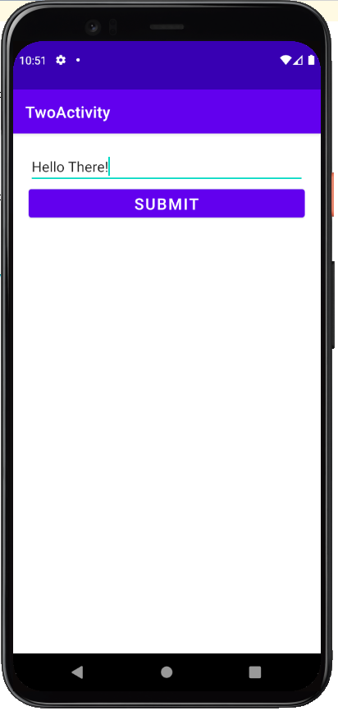
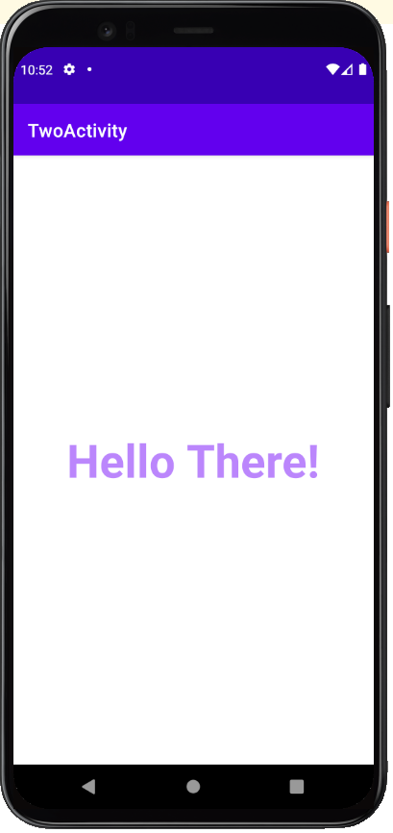
Objective of Practical 4:
Create an application with first activity with an editText and send button. On click of send button, make use of implicit intent that uses a SEND ACTION and let user select app from app chooser and navigate to that application.
Code:
activity_main.xml
<?xml version="1.0" encoding="utf-8"?>
<androidx.constraintlayout.widget.ConstraintLayout xmlns:android="http://schemas.android.com/apk/res/android"
xmlns:app="http://schemas.android.com/apk/res-auto"
xmlns:tools="http://schemas.android.com/tools"
android:layout_width="match_parent"
android:layout_height="match_parent"
tools:context=".MainActivity">
<Button
android:id="@+id/btnShare"
android:layout_width="wrap_content"
android:layout_height="wrap_content"
android:text="Share Text"
app:layout_constraintBottom_toBottomOf="parent"
app:layout_constraintLeft_toLeftOf="parent"
app:layout_constraintRight_toRightOf="parent"
app:layout_constraintTop_toTopOf="parent" />
</androidx.constraintlayout.widget.ConstraintLayout>

MainActivity.java
package com.example.implicitintent;
import androidx.appcompat.app.AppCompatActivity;
import android.content.Intent;
import android.os.Bundle;
import android.view.View;
import android.widget.Button;
public class MainActivity extends AppCompatActivity {
@Override
protected void onCreate(Bundle savedInstanceState) {
super.onCreate(savedInstanceState);
setContentView(R.layout.activity_main);
Button btnShare=findViewById(R.id.btnShare);
btnShare.setOnClickListener(new View.OnClickListener() {
@Override
public void onClick(View v) {
Intent intent=new Intent(Intent.ACTION_SEND);
intent.setType("text/plain");
intent.putExtra(Intent.EXTRA_TEXT,"Hello There");
startActivity(intent.createChooser(intent,"Share"));
}
});
}
}

Output:
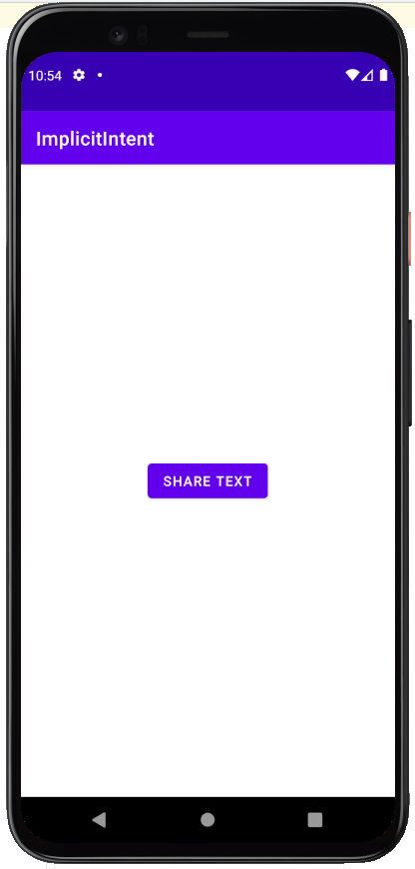
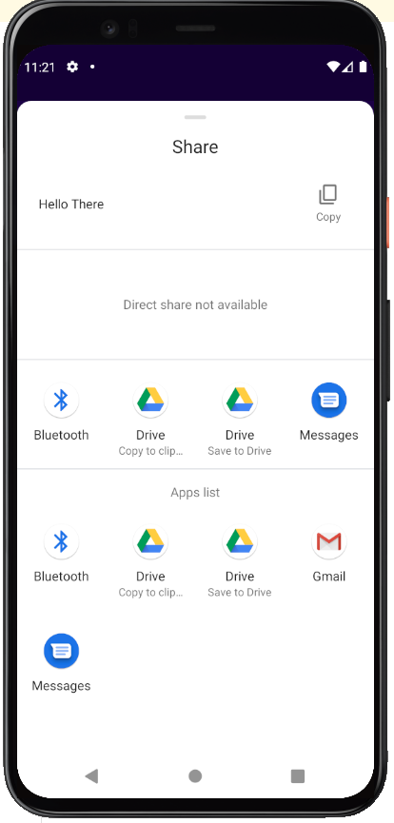
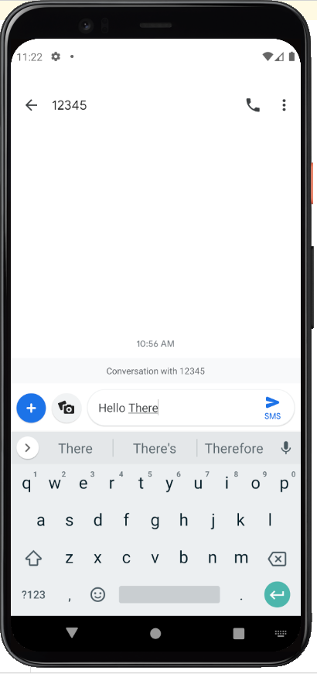

Objective of Practical 5:
Create spinner with strings taken from resource folder (res >> value folder) and on changing the spinner value, Image will change.
Code:
activity_main.xml
<?xml version="1.0" encoding="utf-8"?>
<androidx.constraintlayout.widget.ConstraintLayout xmlns:android="http://schemas.android.com/apk/res/android"
xmlns:app="http://schemas.android.com/apk/res-auto"
xmlns:tools="http://schemas.android.com/tools"
android:layout_width="match_parent"
android:layout_height="match_parent"
tools:context=".MainActivity">
<Spinner
android:id="@+id/spinner"
android:layout_width="0dp"
android:layout_height="wrap_content"
android:layout_marginStart="8dp"
android:layout_marginLeft="8dp"
android:layout_marginTop="16dp"
android:layout_marginEnd="8dp"
android:layout_marginRight="8dp"
app:layout_constraintEnd_toEndOf="parent"
app:layout_constraintStart_toStartOf="parent"
app:layout_constraintTop_toTopOf="parent"
/>
<ImageView
android:id="@+id/image"
android:layout_width="332dp"
android:layout_height="323dp"
app:layout_constraintBottom_toBottomOf="parent"
app:layout_constraintEnd_toEndOf="parent"
app:layout_constraintStart_toStartOf="parent"
app:layout_constraintTop_toTopOf="@+id/spinner"
app:layout_constraintVertical_bias="0.479" />
</androidx.constraintlayout.widget.ConstraintLayout>

MainActivity.java
package com.example.spinner;
import androidx.appcompat.app.AppCompatActivity;
import android.os.Bundle;
import android.view.View;
import android.widget.AdapterView;
import android.widget.ArrayAdapter;
import android.widget.ImageView;
import android.widget.Spinner;
public class MainActivity extends AppCompatActivity {
private Spinner spinner;
private ImageView image;
@Override
protected void onCreate(Bundle savedInstanceState) {
super.onCreate(savedInstanceState);
setContentView(R.layout.activity_main);
spinner=findViewById(R.id.spinner);
image=findViewById(R.id.image);
String [] birds={"Select One","Flamingo","Macaw","Kingfisher","Toucan"};
ArrayAdapter<String>adapter=new ArrayAdapter<String>(this,android.R.layout.simple_spinner_dropdown_item,birds);
spinner.setAdapter(adapter);
spinner.setOnItemSelectedListener(new AdapterView.OnItemSelectedListener() {
@Override
public void onItemSelected(AdapterView<?> parent, View view, int position, long id) {
switch (position){
case 1:
image.setImageResource(R.drawable.flamingo);
break;
case 2:
image.setImageResource(R.drawable.macaw);
break;
case 3:
image.setImageResource(R.drawable.kingfisher);
break;
case 4:
image.setImageResource(R.drawable.toucan);
break;
}
}
@Override
public void onNothingSelected(AdapterView<?> parent) {
}
});
}
}
Output:
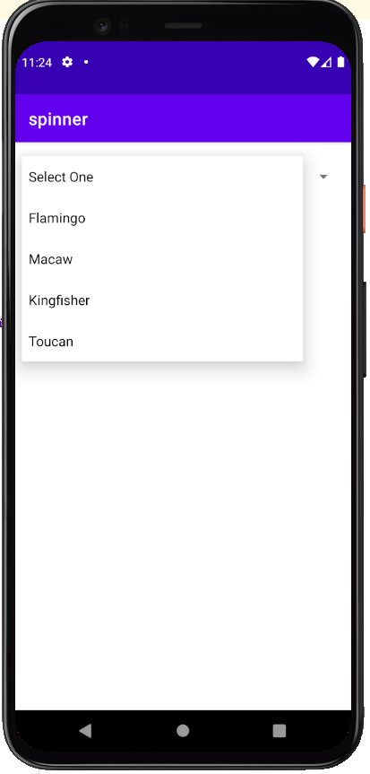
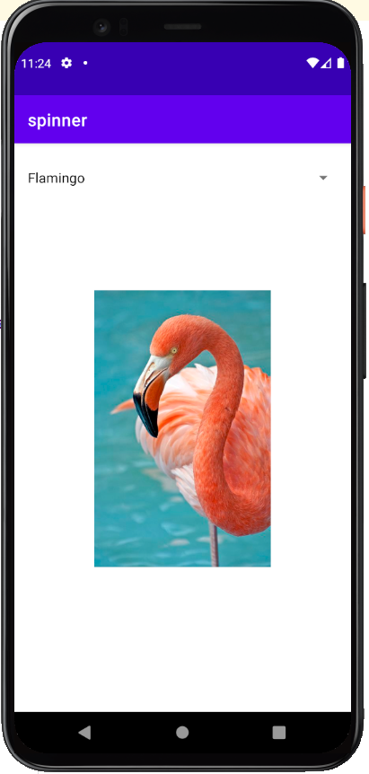
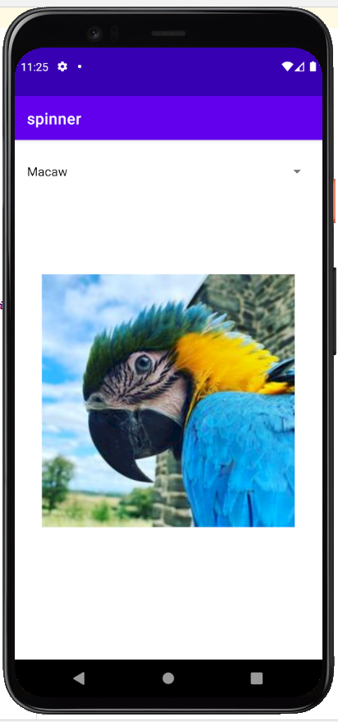
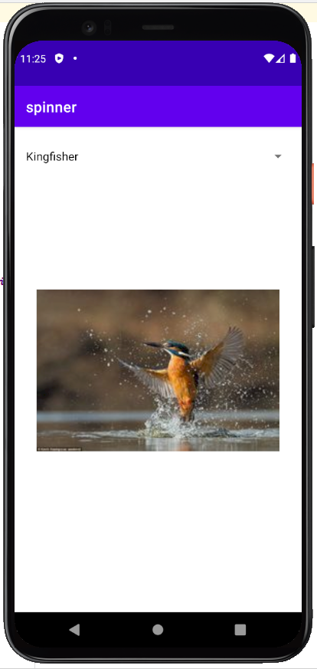
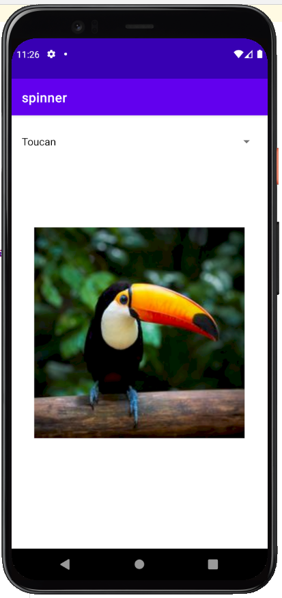
Objective of Practical 6:
Create a menu with 5 options and selected option should appear in text box in upper case.
Code:
activity_main.xml
<?xml version="1.0" encoding="utf-8"?>
<androidx.constraintlayout.widget.ConstraintLayout xmlns:android="http://schemas.android.com/apk/res/android"
xmlns:app="http://schemas.android.com/apk/res-auto"
xmlns:tools="http://schemas.android.com/tools"
android:layout_width="match_parent"
android:layout_height="match_parent"
tools:context=".MainActivity">
<RelativeLayout
android:layout_width="match_parent"
android:layout_height="match_parent"
android:layout_margin="80dp"
app:layout_constraintBottom_toBottomOf="parent"
app:layout_constraintLeft_toLeftOf="parent"
app:layout_constraintRight_toRightOf="parent"
app:layout_constraintTop_toTopOf="parent">
<EditText
android:layout_width="match_parent"
android:layout_height="wrap_content"
android:id="@+id/etMenuItem"
android:layout_centerInParent="true"
android:hint="Select an Option from the Menu"
android:textAlignment="center"
android:gravity="center_horizontal" />
</RelativeLayout>
</androidx.constraintlayout.widget.ConstraintLayout>

MainActivity.java
package com.example.menuwithoptions;
import androidx.appcompat.app.AppCompatActivity;
import android.os.Bundle;
import android.view.Menu;
import android.view.MenuInflater;
import android.view.MenuItem;
import android.widget.EditText;
public class MainActivity extends AppCompatActivity {
private EditText etMenuItem;
@Override
protected void onCreate(Bundle savedInstanceState) {
super.onCreate(savedInstanceState);
setContentView(R.layout.activity_main);
etMenuItem=(EditText) findViewById(R.id.etMenuItem);
}
@Override
public boolean onCreateOptionsMenu(Menu menu){
MenuInflater inflater=getMenuInflater();
inflater.inflate(R.menu.main_menu,menu);
return true;
}
@Override
public boolean onOptionsItemSelected(MenuItem item){
etMenuItem.setText(item.getTitle().toString().toUpperCase());
return super.onOptionsItemSelected(item);
}
}
main_menu.xml
<?xml version="1.0" encoding="utf-8"?>
<menu xmlns:android="http://schemas.android.com/apk/res/android">
<item
android:id="@+id/miSettings"
android:title="@string/settings" />
<item
android:id="@+id/miBackup"
android:title="@string/backup" />
<item
android:id="@+id/miReset"
android:title="@string/reset" />
<item
android:id="@+id/miAbout"
android:title="@string/about" />
<item
android:id="@+id/miHelp"
android:title="@string/help" />
</menu>

Output:


  

